- ( ) Don’t always down the answers from
the book. That’s a bad habit.
(Ａ) copy (Ｂ) stay (Ｃ) call (Ｄ) interest
- ( ) Bob enjoys taking . Most of them are
about trains.
(Ａ) tips (Ｂ) letters (Ｃ) photos (Ｄ) types
- ( ) Mom: Have you finished homework?
Tom: Not .
(Ａ) already (Ｂ) yet (Ｃ) lately (Ｄ) ever
- ( ) Our school is going to have a relay next
week. All my classmates work hard and try to
win first place.
(Ａ) envelope (Ｂ) drum (Ｃ) gym (Ｄ) race
- ( ) Mary was caught by the teacher when she was
______ on the tests.
(Ａ) wishing (Ｂ) understanding
(Ｃ) cheating (Ｄ) taking
- ( ) Jimmy has never slept in class; he _____ a good
example for his classmates.
(Ａ) downloads (Ｂ) sets
(Ｃ) spells (Ｄ) guesses
- ( ) Students have to stay home for days
because of the COVID-19.
(Ａ) several (Ｂ) bored (Ｃ) fake (Ｄ) proud
- ( ) Dora dried her body with a big after
swimming in cold water.
(Ａ) bat (Ｂ) comb (Ｃ) towel (Ｄ) hit
- ( ) Children usually go - or - treating on
Halloween to ask for sweets.
(Ａ) post (Ｂ) dig (Ｃ) lie (Ｄ) trick
- ( ) The science exam was so difficult that
passed it. We all failed.
(Ａ) someone (Ｂ) everyone
(Ｃ) nobody (Ｄ) anybody
- ( ) Cathy: have you lived in Japan?
Rita: I have lived in Japan for two years.
(Ａ) How long (Ｂ) How old
(Ｃ) How often (Ｄ) How much
- ( ) My husband fruit salad for lunch yesterday.
(Ａ) was having (Ｂ) had (Ｃ) has had (Ｄ) has
- ( ) Nina for the exam a long time .
(Ａ) have prepared; for
(Ｂ) has prepared; since
(Ｃ) have prepared; since
(Ｄ) has prepared; for
- ( ) John: you go to the concert with me
next year?
Eric: No problem.
(Ａ) Will (Ｂ) Were (Ｃ) Are (Ｄ) Have
- ( ) Willy’s too much time playing online
games lately, so he didn’t finish his homework.
(Ａ) taken (Ｂ) cost (Ｃ) spent (Ｄ) paid
- ( ) My sister decided weight, so she started
exercising.
(Ａ) lose (Ｂ) to lose (Ｃ) lost (Ｄ) losing
- ( ) The movie is so that I’ve watched it lots
of times.
(Ａ) boring (Ｂ) interesting
(Ｃ) bored (Ｄ) interested

- ( ) The iPhone 14 Pro is expensive for me
buy.
(Ａ) so; that (Ｂ) enough; to
(Ｃ) very; that (Ｄ) too; to
- ( ) Peter and Wendy are surprised the
Christmas presents.
(Ａ) in (Ｂ) with (Ｃ) at (Ｄ) about
- ( ) The baseball game was . When we watched
it, we all felt .
(Ａ) exciting; excited (Ｂ) excited; excited
(Ｃ) exciting; exciting (Ｄ) excited; exciting
- ( ) Look at the picture. What’s the topic of the lesson?
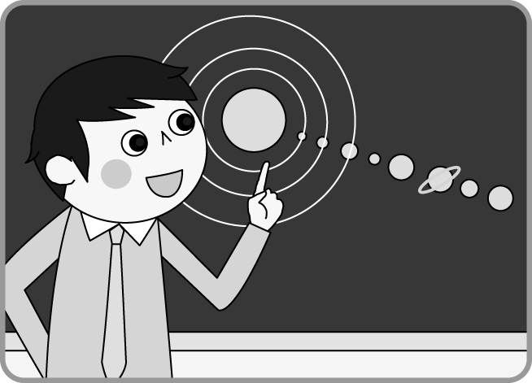
(Ａ) Business. (Ｂ) Planets. (Ｃ) Seats. (Ｄ) Cameras.
- ( ) Because of COVID-19, the resturant was closed last year, but now it’s open to the
again. (Ａ) bath (Ｂ) tail (Ｃ) uniform (Ｄ) public
- ( ) I don’t feel good… Could you tell me where the is?
(Ａ) restroom (Ｂ) dot (Ｃ) dictionary (Ｄ) prize
- ( ) Sorry, Mr. Chen. I forgot to bring my Science to school.
(Ａ) pin (Ｂ) bow (Ｃ) workbook (Ｄ) hobby
- ( ) The woman with a of pearls around her neck plays a queen in the movie.
(Ａ) square (Ｂ) bottom (Ｃ) exercise (Ｄ) string
- ( ) I looked for my ring in the house, but I couldn’t find it. It must be
in the dining room or my bedroom.
(Ａ) ahead (Ｂ) somewhere (Ｃ) perhaps (Ｄ) everywhere
- ( ) The thick snow has the top of Hehuan Mountain. What a beautiful sight! (Ａ) smoked (Ｂ) taped (Ｃ) covered (Ｄ) noticed
- ( ) I don’t want to eat cold food. Could you it up for me?
(Ａ) lie (Ｂ) draw (Ｃ) rise (Ｄ) heat
- ( ) Because Tom would leave for Japan, he classmates to his house for a
farewell party. (Ａ) invited (Ｂ) appeared (Ｃ) rose (Ｄ) arrived
- ( ) The National Palace Museum is famous in the world, and lots of
come to Taiwan for it each year.
(Ａ) jokes (Ｂ) visitors (Ｃ) spells (Ｄ) apartments
- ( ) Anyone wants to play badminton can join the school club.
(Ａ) × (Ｂ) where (Ｃ) who (Ｄ) which
- ( ) Amy: Who’s the girl a red dress? Nina: It’s my sister, Mary.
(Ａ) with (Ｂ) on (Ｃ) at (Ｄ) in
- ( ) The teacher long hair from France.
(Ａ) in; is (Ｂ) with; comes (Ｃ) in; comes (Ｄ) with; come
- ( ) Eric is one of the boys ______ playing the guitar very much. They are going to
make a band soon.
(Ａ) that hates (Ｂ) who enjoy (Ｃ) who is poor at (Ｄ) which are good at
- ( ) The movie I saw this afternoon is so exciting that I want to see it again. (Ａ) that (Ｂ) when (Ｃ) what (Ｄ) who
- ( ) The song you’re listening to is Ed Sheeran’s.
(Ａ) who (Ｂ) why (Ｃ) × (Ｄ) how
- ( ) The man who drawing picture books ten years ago is an anime maker now.
(Ａ) loves (Ｂ) loved (Ｃ) is loving (Ｄ) has loved
- ( ) When my parents got home, I the comic book which Charles gave me.
(Ａ) read (Ｂ) will read
(Ｃ) was reading (Ｄ) have read
- ( ) The shopkeeper noticed the boy who walked the dog a funny hat.
(Ａ) is wearing (Ｂ) to wear (Ｃ) wears (Ｄ) wear
- ( ) Father has me the car that has two doors tomorrow afternoon .
(Ａ) washes (Ｂ) wash (Ｃ) to wash (Ｄ) washing
- ( ) The fantasy novel which was written by Tolkien me $900 three years ago.
(Ａ) cost (Ｂ) took (Ｃ) paid (Ｄ) spent

