一、聽力測驗, 共三大題, 10小題, 每題唸兩遍 20%(每題2分)
(一)辨識句意：每題均有三張圖片，請依據所聽到的句子，選出符合描述的圖片
- (A) 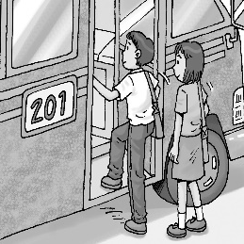 (B) 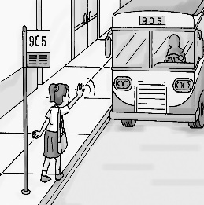 (C) 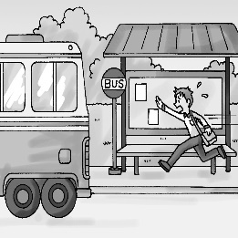
- (A) 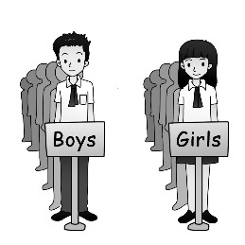 (B) 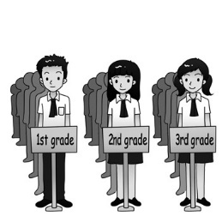 (C) 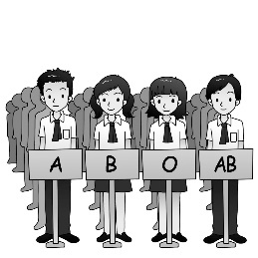
- (A) 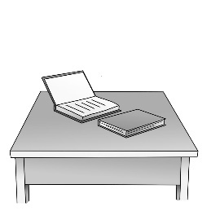 (B) 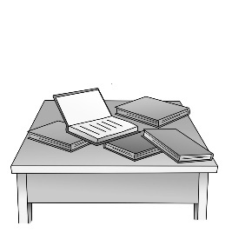 (C) 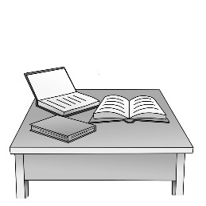
(二)基本問答：每題均有三個選項，請依據所聽到的內容，選出一個最適合的回應
- (A) No, I didn’t touch that.
(B) Yes, but after I finish my LINE messages.
(C) Yes, let’s add each other as friends.
- (A) Sorry. I changed my mind.
(B) Let’s keep in touch.
(C) Here are the findings.
- (A) Maybe you can take it away.
(B) Maybe you can order another one.
(C) Maybe you can turn it off.
(三)言談理解：每題均有三個選項，請依據所聽到的對話與問題，選出一個最適當答案
- (A) After she takes their son to school.
(B) When she finds out why Eric’s teacher called the man.
(C) As soon as she arrives at the school.
- (A) To keep an eye on Peter.
(B) To keep a secret.
(C) To keep a secret.
- (A) The pink shirt is for Ellen, and another is for Maggie.
(B) The pink shirt is for Ellen, and the others are for Maggie.
(C) The pink shirt is for Ellen, and others are for Maggie.
- (A) Actions speak louder than words.
(B) Helping the poor is not the man’s business.
(C) The man could pass on the idea of helping others.
二、單題:30%
- Our homeroom teacher, Mr. Hsu, always says that we need to think about others. He also says that we can’t just ourselves.
(A) bring about (B) care about (C) talk about (D) stand about
- Although we may not have enough time to prepare for the big tests, we can still
. (A) do nothing (B) do our best (C) do the hair (D) do the cleaning
- Ms. Bewell: Honey, it’s really cold today. Please your coat now.
Jonathon: OK, Mom. I will. Just a minute.
(A) get on (B) feed on (C) put on (D) pass on
- The monkey on the TV show can do a special trick. It can stand on one hand and eat the banana with . (A) another (B) other (C) others (D) the other
- Jenna: Today’s math homework is so difficult. I don’t think I can do it.
Ms. Walton: Don’t it. Maybe you can ask Dad for help.
(A) worry about (B) give up (C) put away (D) take out
- Dubai be a small fishing village, but now it’s full of tall buildings.
(A) decided to (B) wanted to (C) had to (D) used to
- Many people were the news that Dick Hoyt died on March 17 this year. He was a loving father and was famous for leading his son in triathlon games.
(A) grouped by (B) shocked by (C) created with (D) covered with
- We all hope people who we help can the idea of helping others.
(A) pass on (B) pass by (C) pass away (D) pass down
- Peter: I heard from the news that some people changed their name to the name of a kind of fish to get free sushi. I will never do things like that. Mary:
(A) So will I. (B) So do I. (C) Neither will I. (D) Neither do I.
- Smokers will find it is really difficult to smoke in a public space.
(A) who (B) that (C) if (D) how
- Ariel: Do you know Neil Armstrong said when he first landed on the moon? Melissa: I don’t know. Maybe we can ask our teacher.
(A) what (B) when (C) where (D) how
- Bob: Mom, I need my watch. I can’t find it. Mom: Here .
(A) you are (B) is it (C) your watch is (D) are you
- If you use your smartphone wisely, maybe it can save your life when you are . (A) in class (B) in danger (C) in love (D) in action
- My parents say that as soon as the big tests in May over, they will take my brother and me to Kenting for a trip. (A) is (B) be (C) are (D) were
- A young man was told that he couldn’t change his name anymore because his mom
his name twice when he was little.
(A) has changed (B) will change (C) was changing (D) had changed
三、題組:24%
(26-27)
Love Others
Red and yellow, black and white
They are special in their parents’ sight
They look different but inside they are the same
They all need love even though they have different names

Love is in everyone
We are to build bridges, not walls
No man on earth is better than another
We should all love and care about each other

Try always to be nice and kind
To be loving is much better I find
Speak softly so others won’t hurt
Kind words are as sweet as dessert

Try to follow your heart and it’s better by far
So others in this world will not scare
Love and care may seem a small thing
But much good and joy to all it will bring

~ Dolly Harries
seem 似乎

- What does “Red and yellow, black and white” mean?
(A) The colors of the bridges.
(B) The colors the writer likes a lot.
(C) The colors of the desserts the writer makes.
(D) The colors of different kinds of people in the world.

- Why does the writer write the poem?
(A) She wants to build bridges.
(B) She likes to paint the walls with colors.
(C) She hopes everyone on earth to love one another.
(D) She wishes to speak more softly and bring joy to others.

(28~30) March 31, 2021
Dear Grandma,
It’s been a long time since we last saw you and Grandpa. Because of the COVID-19 pandemic, we can’t travel a lot. We can’t pay you a visit now. We miss both of you so much. I also miss the “magic dessert” that you used to make for us. I wanted to eat it so much that I tried to make some by myself. Here are what I used and how I made them.
Ingredients 1/2 tablespoons of baking powder
2 cups of flour 2 eggs 2 cups of milk
2 tablespoons of butter 5 tablespoons of sugar
Some fruit you like (such as strawberries, cherries, or blueberries)
How to make them
- Take a bowl and put in the dry ingredients. Mix them together.
- Add the eggs and milk. And mix everything until it becomes a batter.
- Let the batter rest for a few minutes.
- Take a skillet, and use a medium heat to heat it up.
- Put in some butter and then add some batter. Make it a round piece.
- Cook it until it begins to bubble.
- Turn it over and cook the other side.
- Take it out when both sides are brown.
- Keep on cooking the others. Then put all the pieces together on a dish.
- Put some fruit on top of them. My favorite is strawberries.
- Enjoy the “magic dessert”
Here is a picture of the magic dessert I made. It was not as delicious as yours, but I guess I will have to do it all by myself until next time we meet. Hope to see you and Grandpa soon.
Love,
ingredient 材料 batter 麵糊 bubble 冒泡泡 Sylvia
- What can we learn from the letter?
(A) Sylvia can’t cook by herself.
(B) It takes seven steps to make the magic dessert.
(C) Sylvia and her grandparents lived together before.
(D) You need seven ingredients to cook the magic dessert.
- What may the picture Sylvia sent to her grandma be like?
(A)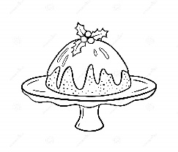 (B)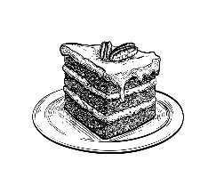 (C)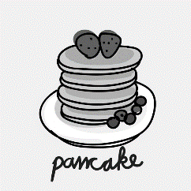 (D)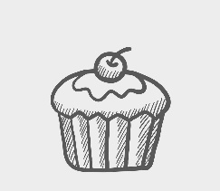
- What does a skillet mean?
(A) Something used to eat with. (B) Something used to drink with.
(C) Something used to cook with. (D) Something used to write with.

(28~31)
Mr. Wu is a farmer with little education, but he (31) dozens of robots by himself over the past thirty years.
When he was asked why he wanted to build the robots, he answered, “When I was eleven, one day I was bored and sat at the window watching people (32) by. An idea suddenly came to me: Why not build a machine that walks like a human being?”
It took Mr. Wu several years to build his first robot. The robot could move in small steps, but it couldn’t raise its legs. Later his designs (33) better and better. Now his robots are able to climb walls, serve water, play the guitar, and even write.
Mr. Wu (34) all the robots as his sons, and calls them from Wu No.1 to Wu No. 26. Wu No. 25 is his favorite “son.” Why? Because Wu No. 25 pulls the cart for his “father” around the village every day. It can work for six hours on only one battery.
education 教育 human being 人類 serve（給某人）端上 battery 電池
- (A) has built (B) build (C) to build (D) building
- (A) walked (B) walking (C) to walk (D) walks
- (A) have become (B) becomes (C) became (D) will become
- (A) will see (B) saw (C) had seen (D) sees
(35~37)
What is the best way to catch someone who is telling a lie?
For a long time, the way to tell whether one was lying or not was to watch their body language. What if the person appears to be nervous? Is the person unable to look me in the eyes? Is he or she looking around the room? What about other nervous actions, such as playing with fingers or walking around?
Many people – from parents to police officers and airport workers– use this method to find out who’s not telling the truth. But does a person’s body and face help us find out the truth? Not according to a new study done at an airport. The study showed that the best way to tell if someone may be telling a lie is to talk to the person.
In the study, the researchers asked volunteers to pretend they were real travelers and then lie to airport workers. Some of the workers questioned these make-believe travelers by talking with them. Others used the person’s body language. The workers talking with the travelers were 20 times more likely to catch those who were telling a lie. When it comes to telling who is lying, talking works. Body language cannot explain everything.
According to the study, they listed some ways to tell whether one is lying or not. Here are three of them.
1. Use open-ended questions. Unlike “Yes -No” questions, open-ended questions made the person keep on telling the story of their lies until they were caught in their own net of lies.
2. Make the most of surprise. Ask questions they may not think you are going to ask. Ask questions that are surprising. This will make it harder for them to keep lying. Or better still ask them to re-tell a story, going from the nearest thing to the earliest. This is hard enough to do with the truth, let alone a story of lies.
3. Look for small things that do not add up. Ask them small things about their story and look for facts that don’t appear to agree with each other. But do not let them know you know. Just let them dig themselves deeper into a hole.
Maybe this method can help police officers and airport workers do their jobs easier. Don’t you think so?
nervous 緊張的 method 方法 researcher 研究人員 pretend 假裝
- What is the reading about?
(A) To share with us some findings from a study.
(B) To tell whether we are lying or not.
(C) To teach us how to ask good questions.
(D) To show us how to tell a lie and not to be found out.
- According to the reading, what should we do to catch someone in a lie?
(A) Ask only Yes – No questions. (B) Look people in the eyes.
(C) Talk with them as much as possible. (D) Play with fingers and walk around.
- If people “dig themselves deeper into a hole”, what may they do?
(A) They may tell the truth. (B) They may dig a deep hole on the ground.
(C) They may feel nervous. (D) They may keep on telling lies.
四、手寫題:26%
A. 中翻英：請寫出下列英文單字（每題2分，錯1處扣1分）12%
- 開玩笑 | - 打包 | - 筆記
- 錢包 | - 票 | - 每天的
B.引導式翻譯（每格2分）14%
- 在老師進來之前，學生已經把教室打掃乾淨了。
The students had (1) up the (2) before the teacher came in.
- 他以前下班後會去慢跑。
He used to (1) jogging after (2) .
- 因為我們的老闆生病，所以這場會議已經被延後了。
Because our boss is (1) , the (2) has been (3) off.
試題結束，請交回電腦卡及手寫卷

