桃園縣立楊明國中103學年度第一學期九年級英語科第一次段考
九年級 ______班 _____號 姓名: ___________
***第1題至第38題請在電腦卡上作答 第39題至第58題請寫在答案卷上. ***
***第1 ~ 15題為聽力測驗,請仔細聆聽.***
0一. 聽力測驗。每題2分，共30分
A.辨識句意: 根據聽到的內容,選出符合圖片的描述.
1.（ ）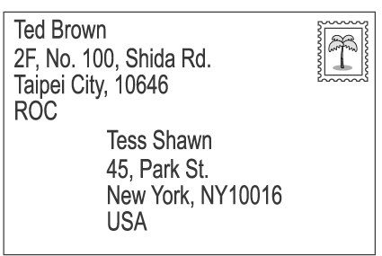 4.（ ）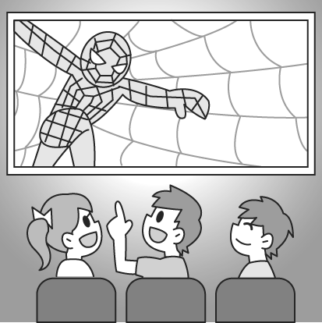
2.（ ）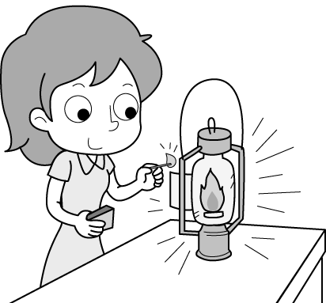 5.（ ）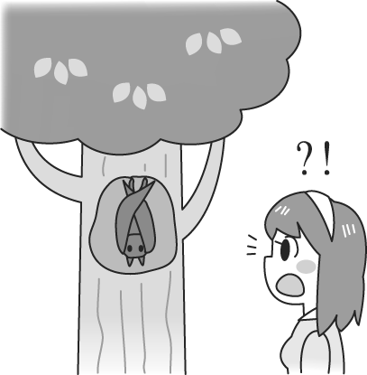

3.（ ）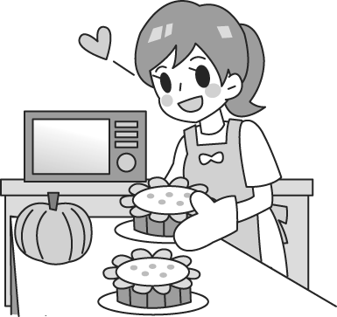 6.（ ）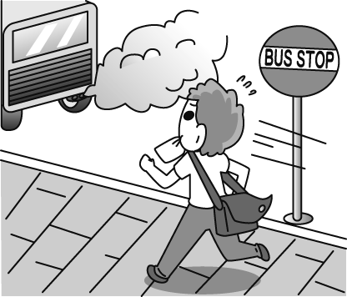

- 基本問答:根據聽到的內容,選出一個最適合的回應或問句.
( ) 7. (Ａ) Isn’t that museum a good place to know more about Hakka culture?
(Ｂ) Can I? I’ve never visited it, and I really want to go.
(Ｃ) Of course. Hope to hear from you in a short time.
( ) 8. (Ａ) I enjoy the life in the ocean. (Ｂ) You can say that again. Let’s help take care of Pi.
(Ｃ) Really? Can I go with you tonight?
( ) 9. (Ａ) We will have a big dinner at the table during the Chinese New Year, won’t we?
(Ｂ) Well, I like a round one better. “Round” means “perfect”.
(Ｃ) Let’s draw five squares on the piece of paper.
( ) 10. (Ａ) A butterfly. (Ｂ) Yes, it’s square. (Ｃ) No. Its body is small.
( ) 11. (Ａ) The princess turned into a frog. (Ｂ) They didn’t seem to like the story.
(Ｃ) They bought the book without knowing the story.
( ) 12. (Ａ) Right! The rain and wind last night was terrible.
(Ｂ) Sorry. I would like to watch it with you, but I can’t.
(Ｃ) That’s true. The players even fought at the end of the game.
- 言談理解: 根據聽到的內容,選出一個最適合的答案。
( ) 13. (Ａ) A Halloween parade. (Ｂ) A Christmas party.
(Ｃ) An interesting game for New Year.
( ) 14. (Ａ) The way to make paper umbrellas. (Ｂ) Lady Gaga’s concert.
(Ｃ) The present for Lady Gaga.
( ) 15. (Ａ) He’s been a wonderful artist. (Ｂ) He has to practice and learn more.
(Ｃ) He must find better ways to sell his works of art.

二‚ 單題: 依據題意選出一個最佳的答案 30% (每題2分)
( D ) 16. If I am free, I’ll phone you back as soon as _______. (A. flat B. wooden C. excellent D. possible)
( B ) 17. Although Mrs. Chang has everything, she still feels ________ with her life and wants more.
(A. excited B. bored C. surprised D. scared)
( A ) 18. My sister is getting married. The hearts of all my family are _____ with joy.
(A. filled B. crazy C. creative D. surprised)
( D ) 19. Helen is always at the ____ of her class. It means that she always gets the best grades in her class.
(A. mask B. luck C. wish D. top)
( A ) 20. Chinese is our first ______, and we have English as a foreign _______.
(A. language; language B. program; square C. measurement; kilometer D. costume; leather)
( C ) 21. A: _____ has Eric been a teacher? B: He has been a teacher ______ ten years.
(A. How often; for B. What time; for C. How long; for D. How long; since)
( B ) 22. Both Jessica and Emma ________ to Europe. They are not in Taiwan now.
(A. have been B. have gone C. have visited D. have taken)
( C ) 23. Eva likes to ______, so nobody likes to be together with her.
(A. fill up B. put on C. show off D. get to)
( D ) 24. Sharon has loved Taiwanese beef noodles _______ she first came to Taiwan.
(A. after B. when C. before D. since)
( A ) 25. I don’t know when they will arrive. I haven’t ______ them yet.
(A. heard from B. heard of C. dressed up D. in time)
( B ) 26. How tall is the kid? He’s a ______ boy. (A. 5-feet-tall B. 5-foot-tall C. 5 feet)
( B ) 27. My mother’s eyesight is getting weak. She can’t see clearly _____ wearing glasses.
(A. with B. without C. besides D. on)
( D ) 28. Halloween is a(n) ______ holiday for children in the USA because they get to go trick-or treating.
(A. excited B. scared C. proud D. exciting)
( C ) 29. A: Have you ever been to Japan? B: No, _____.(A. I have B. I don’t C. I never have D. yet)
( A ) 30. Mia _____ that she could go to the museum on foot, and she did it.
(A. thought B. thinks C. will think D. think)

三, 題組(一): 根據題意選出最佳答案 (每題2分) 10%
Making a living (維生) in a small town is not easy. But a small town also has a good chance of __31__ that can bring a lot of money, if it has something special to be proud of. One example is Gukeng town of Yunlin, Taiwan. Gukeng has long __32__ famous for growing good coffee, but the town didn’t start to make much money from it _33__ some years ago. As (隨著) more and more people have visited Gukeng for its coffee, the coffee farmers have begun to open their farms to the public. At those farms, people can have the fun of finding out where coffee comes from. __34_, coffee shops have opened all over Gukeng town, and people can take a rest and taste delicious coffee on the sidewalks in or after an __35__ day’s visit.
The new business makes a better life possible for those who live in the town. They don’t have to leave the town to find jobs in other places.
( C ) 31. (A. selling old framing lands B. opening a shopping mall
C. starting a new business D. growing the best tea)
( A ) 32. (A. been B. is C. was D. be)
( D ) 33. (A. since B. for C. when D. until)
( B ) 34. (A. First B. Besides C. For example D. However)
( C ) 35. (A. interest B. interested C. interesting D. interested in)
題組(二): 根據題意選出最佳答案 (每題1分) 3%
One certain airline decided that people who are too big have to buy two plane tickets. As (隨著) with many new rules, some people are happy about it, but others are not. Those who are happy about it say they are tired of sitting next to large people on airlines because they take up (佔據) not only their own seats but also part of their neighbor’s. Those people who can fit into their seats ask why they have to pay full price for a ticket if they only get to sit in half of their seat. They think larger people should buy two seats, so they will not take up the seat of anybody sitting next to them. But there are others who do not agree the rule. They see the rule as a kind of discrimination against (針對 ….. 歧視) large people. They believe that airlines are just trying to make more money by making large people pay more. What do you think? (not only … but also: 不僅 ... 而且)
( C ) 36. Who are they in the reading?
(A. Airlines. B. The neighbors. C. Large people. D. Happy people.)
( A ) 37. Why do large people have to pay more?
- They need more space. B. They eat more. C. They are not friendly. D. They make more money.)
( B ) 38. According to (根據) the reading, can slim people pay half of the price for a plane ticket?
- Yes. B. No.)

<< 答 案 卷 >>
九年級 ______班 _____號 姓名: ___________

四, 寫出下列動詞的過去分詞: 10% (每題1分)
39. try __________ 40. pay ______________ 41. clap _____________ 42. put __________

43. read ___________ 44. feed _____________ 45. draw ____________ 46. know ________

47. speak __________ 48. bring _____________

五, 寫出附加問句及其答句: (每格1分) 12%
49. Going to bed early is important, isn’t _________?
50. The actress always gets to work on time, (1) _________ (2) ___________?
51. A: The woman should turn off her cellphone, shouldn’t she?
B: Yes, (1) _______ (2) _________.
52. A: There isn’t a dog on the floor, is there?
B: No, (1) _______ (2) _________.
53. These fishermen have seen a whale, _________ they?
54. Nothing bad happened, _________ it?
55. Students have to follow school rules, __________ they?
56. I am right, (1) ______ (2) ________?

六, 翻譯填空: (每格1分) 5%
57. 除了小孩, 許多大人因為萬聖節遊行也對這節日感到興奮.
Besides children, many adults also get (1) __________ (2) __________ this holiday because (3) _________ Halloween parades.
58. 每個人都知道妳天不怕地不怕的.
Everyone knows (1) ___________ you aren’t afraid (2) ________ anything.

------------------------------------------------------------------------------------------------------------------------------------
*** 考試完畢,請將電腦卡,答案卷繳回 ***

