第一部分：聽力測驗：每題2分，共30分。
ㄧ、聽CD，選出所聽到的字詞。
( ) 1. (A) east (B) west (C) city
( ) 2. (A) June (B) July (C) May
( ) 3. (A) may (B) mad (C) map
( ) 4. (A) corner (B) middle (C) right
( ) 5. (A) contest (B) concert (C) corner
( ) 6. (A) straight (B) contest (C) second

二、聽CD，若符合圖意或表格內容的選 A，否則選 B。
 | 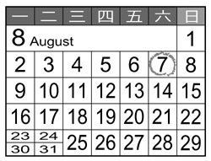 |  | 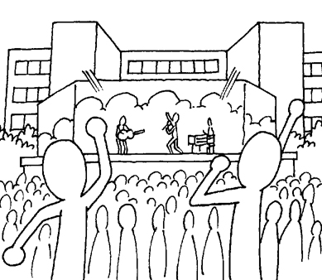
 | 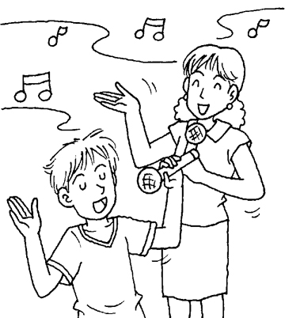 |  | 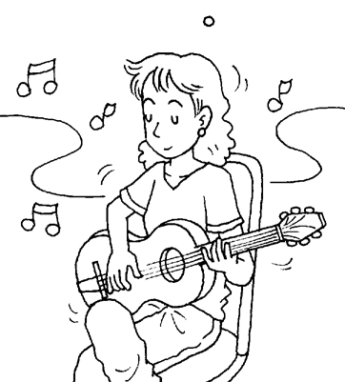
 | 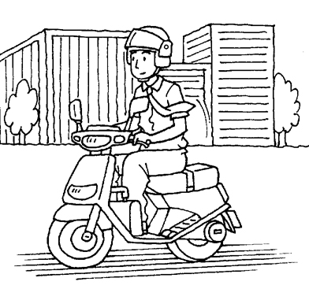 |  | 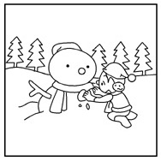
 | 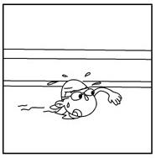

三、聽CD中的對話，選出適當的答案。
( ) 14. (A) She will fly to Taichung.
(B) She will drive to Taichung.
(C) She will walk to Taichung.
( ) 15. (A) He wants to become more famous.
(B) He wants to make more friends.
(C) He wants to help the poor.

第二部分：讀寫測驗：每題/格2分，共70分。
一、句子的描述與圖片相符請選(A)，不符請選(B)。
 | 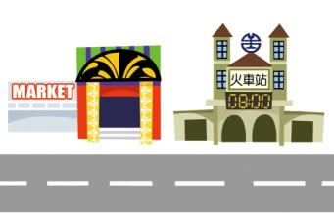 | The market is next to the train station. (A)
 |  | Joe dicided to help people in Nepal, so he started to raise money on the Internet.(B)
 | 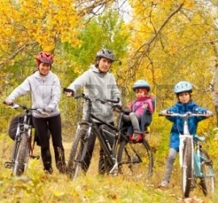 | My family often go fishing in autumn. (B)
 | 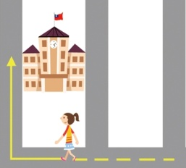 | Go straight for two blocks and turn left at the corner. You will see the school. (B)
 | 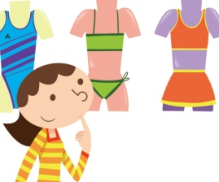 | Linda is going to buy a new swimsuit next week. (A)

二、選擇最適當的答案。
( ) 21. The first Mickey Mouse cartoon in 1928.
(A) looked out (B) came out
(C) watched out (D) put out
( ) 22. To , they are going to show some new Disney cartoons.
(A) wear (B) laugh (C) celebrate (D)visit
( ) 23. It was not easy to move money around before. Now modern makes it much easier.
(A)tower (B) model (C) bridge (D) technology
( ) 24. There are four in a year: they are spring, summer, autumn, and winter .
(A) weeks (B) months (C) seasons (D) days
( D ) 25. The tickets to Jody Chiang’s goodbye ________ were sold out in thirty minutes.
(A) concerts (B) contests (C) songs (D) fans
( B) 26. He has a/an for a job next Thursday.
(A) interview (B)sight (C) prize (D) career
( ) 27. The stores have to ________ for customers(顧客) in the Christmas season.
(A) contest (B) compete
(C) comfortable (D)cyclone
( ) 28. What time does the plane ________ in New York?
(A) check (B) visit (C) pick (D) arrive
( ) 29. There ________ a big game tomorrow. I feel nervous.
(A) have (B) be (C) will have (D) will be
( B ) 30. A: can I get to the bank?
B: First, go straight and go past the restaurant. Then, turn right at the corner. You’ll see it.
(A) What (B) Why (C) How (D) When
( B ) 31. A: is the weather in New York in spring?
B: a lot of rain.
(A) What/ They have (B) What/ It is
(C) How/ There is (D) How/ There are
( B ) 32. A: I am going the ukulele this winter vacation.
B: Great! Maybe we can have a concert next semester. You play the ukulele, and I play the piano.
(A) to learn (B) learning
(C) learn (D) to learning
( B ) 33. A: I have butterflies in my stomach now.
B: Why? You seldom worry about anything.
A: I’ll have a big test tomorrow.
B: Take it easy. Just study hard. You will get good grades.
Q: What is the girl worrying about?
(A) She worries about everything.
(B) She doesn’t want to catch butterflies.
(C) She is afraid of studying at home.
(D) There will be a test tomorrow.
三、克漏字。
When there is a snow day in Toronto, the kids stay home and take the day off school. In 1999, there was a huge snowstorm. There was so 34 snow that it made driving very unsafe. The city’s 35 didn’t want planes 36 in the air during bad weather, so they cancelled flights. Chris Spence, the head of the Toronto District School Board, decided that 37 might be unsafe for the teachers to drive in the storm, so he had the schools 38 closed for a “snow day.”
(Adapted from teachinkgkidsnews.com)
( ) 34. (A) many (B) much (C) little (D) less
( ) 35. (A) supermarket (B) school
(C) bookstore (D) airport
( ) 36. (A) be (B) to be (C) are (D) were
( ) 37. (A) it (B) he (C) they (D) there
( ) 38. (A) to be (B) being (C) were (D) be

四、依據文章內容，選擇最適當的答案。
The day after we arrived in Taiwan, a typhoon hit the island. My family never saw a typhoon, so we were very excited. But people here were very nervous and told us to be careful.
During the typoon, it was very windy and rainy. The wind blew so heavily that once in a while we thought we were going to fall down.
Although it was not convenient for us to move around during the typhoon, we were told that the rain brought enough water for the rest of the year. We felt glad for people living on this island.
(Adapted from Reading Comprehension Skills for Beginners)
( ) 39. What was the weather like on their second day in Taiwan?
(A) Dry but windy. (B) Wet and windy.
(C) It rained little. (D) Windy and sunny.
( ) 40.How did the writer feel when they saw a typhoon inTaiwan?
(A) Nervous. (B) Hot. (C) Excited. (D) Sad.
It was reported that more than 5,600 Canadians went to the hospital because of the injury from hockey, skiing or another winter sport. Most of the injuries were from skiing and snowboarding. More than 2,300 Canadians went to the hospital after they had an accident in either of those sports. Hockey (1,114 injuries) and snowmobiling (1,126) were next on the list of injury-causing sports.
injury受傷
(Adapted from teachinkgkidsnews.com)
( ) 41. What is NOT one of the winter sports in the reading?
(A) Hockey. (B) Snowboarding.
(C) Skiing. (D) Swimming.
( ) 42. According to the report mentioned above, what sports caused the most injures?
(A) Hocky and skiing.
(B) Hocky and snowboarding.
(C) Skiing and snowmobiling.
(D) Skiing and snowboarding.

五、引導式翻譯。每格2分。(直接寫在空格內)
43. A: Can you me the to Gate 7?
（請問七號門怎麼走?）
B: Yes. Go straight for three blocks and you’ll see it.
44. I to see the sights in .
（我等不及要親自看看這些景點。）
45. The weather is cold and .（十一月的天氣寒冷且乾燥。）

※請將此試卷與答案卡一起交回※

