( B )1. Ben: What’s the _______ today? Tina: It’s July third.
(Ａ)day (Ｂ)date (Ｃ)time (Ｄ)month
( A )2. Christmas is next week, and it’s my favorite _________.
(Ａ)holiday (Ｂ)cow (Ｃ)mud (Ｄ)dinner
( C )3. Don’t be _______. You can do it.
(Ａ)lovely (Ｂ)important (Ｃ)nervous (Ｄ)thankful
( D )4. Please wash your hands ________ you eat dinner.
(Ａ)around (Ｂ)also (Ｃ)only (Ｄ)before
( B )5. Seven is my _______ number.
(Ａ)animal (Ｂ)lucky (Ｃ)cry out (Ｄ)when
( D )6. The _____ is the first animal of the Chinese zodiac(十二生肖).
(Ａ)elephant (Ｂ)tiger (Ｃ)monkey (Ｄ) rat
( C )7. Mom: Are you hungry? John: No. I’m ______.
(Ａ)coat (Ｂ)clean (Ｃ)full (Ｄ)some
( A )8. My grandparents’ farm is _____ big.
(Ａ)so (Ｂ)bug (Ｃ)many (Ｄ)any
( C )9. In Taiwan, Teacher’s Day is ____ September.
(Ａ)on (Ｂ)at ( C )in (Ｄ)of
( D )10. Leo: When is the birthday party? Amy: It’s on June ________.
(Ａ)three (Ｂ)thirty ( C )thirteen (Ｄ)third
( A )11. Mother’s Day in Taiwan is on the second Sunday ____ May.
(Ａ)of (Ｂ)in ( C )on (Ｄ)by
( B )12. _______ is the eleventh month of the year.
(Ａ)December (Ｂ)November ( C )October ( D )August
( B )13. It’s ________ first. Today is New Year’s Day.
(Ａ)March (Ｂ)January ( C )April ( D )February
( A )14. There is ____ cat over there.
(Ａ)a (Ｂ)any ( C )some ( D )many
( B )15. There are _______ horses under the tree.
(Ａ)any (Ｂ)some ( C )an ( D )one
( B )16. A: How much is a cup of black tea? B:______
(A)It's not my cup of tea. (B)It's two hundred NT dollars.
(C)They are $300 NT dollars, please. (D)There is one on the table.
( A )17. Carol has a sweet tooth. She likes to have____ every afternoon.
(A)some chocolate cookies (B)some sandwiches
(C)some hamburgers (D)some chicken salad
( D )18. Emily has a party tonight, but she doesn't have enough bowls. You have lots of bowls. Can you____ some to her?
(A)borrow (B)show (C)create (D)lend
( B )19. I'm really hungry. Mom, is lunch ready? May I have______ pizza first, please?
(A) three (B)a little (C)any (D)many
( C )20. ____ part of the painting is important, the bright stars or the dark trees?
(A)What (B)How much (C)Which (D)How many
( A )21. How many guitars does Benny need?
(A)He needs three guitars. (B)They are five hundred dollars.
(C)He needs the pink ones. (D)There are ten guitars on the wall.
( B )22. How many pineapples are there in the box?
(A)We want four. (B)There is only one.
(C)We don't have any pineapples. (D)There are five apples.
[23-26題]
Clerk: Good afternoon. How may I help you?
Brody: Do you have any works of Vincent van Gogh ?
Clerk: Yes, we do. 23. are you looking for?
Brody: I'm looking for Sunflowers and The Starry Night?
Clerk: We have both. Do you want to see 24. ?
Brody: Yes, please let me take a look.
Clerk: 25. .
Brody: Great. How much are these?
Clerk: Sunflowers is eight hundred NT dollars. The Starry Night is nine hundred NT dollars.
Brody: I want this 26. .
Clerk: All right. Please wait a second.
( B )23. (A)Which (B)What (C)Why (D)Where
( B )24. (A)it (B)them (C)one (D)ones
( C )25. (A)See you later. (B)For here or to go ? (C)Here you are. (D)Come on in.
( A )26. (A)one (B)it (C)ones (D)them

[27-28題]
Cafe´ Terrace at Night
Café Terrace at Night is a painting by Vincent van Gogh. The name shows two important parts of the painting, the coffee shop and the night sky.
In the painting, some people are having drinks at the coffee shop. And on the street nearby, some people are walking. This part of the painting is bright yellow. The other part, the night sky, is dark blue. There are some houses under the sky, and they are in dark colors, too.
The two parts, the bright yellow coffee shop and the dark blue night sky, are perfect together. They create a good balance.
( D )27.What is the reading about?
(A)A coffee shop with good drinks. (B)Vincent van Gogh.
(C)The sky and the street at night. (D)The colors in a painting.
( A )28.Where CAN'T we see this reading?
(A)In a movie about houses. (B)In a notebook of an art student.
(C)In a book about paintings. (D)In an art museum.

[29-30題]
S'mores are popular with kids in the USA. The name is short for "some more." It's an easy snack, and everyone loves it.
What do you need?
■ some crackers ■ some chocolate ■ some marshmallows
What do you do?
First, place some chocolate on a cracker. Second, roast a marshmallow over fire. Third, put the marshmallow on the chocolate. Last, put another cracker on top.
What do you get?
You get a yummy s'more. Enjoy it!
( B )29.Who may likely have s'mores in the afternoon?
(A)Ted's grandparents. (B)Liam, a junior high school student. (C)Eric, a six-month-old baby boy. (D)Anita's parents.
( A )30. Which is a s'more?
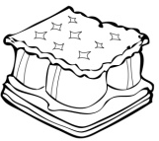  (A) | 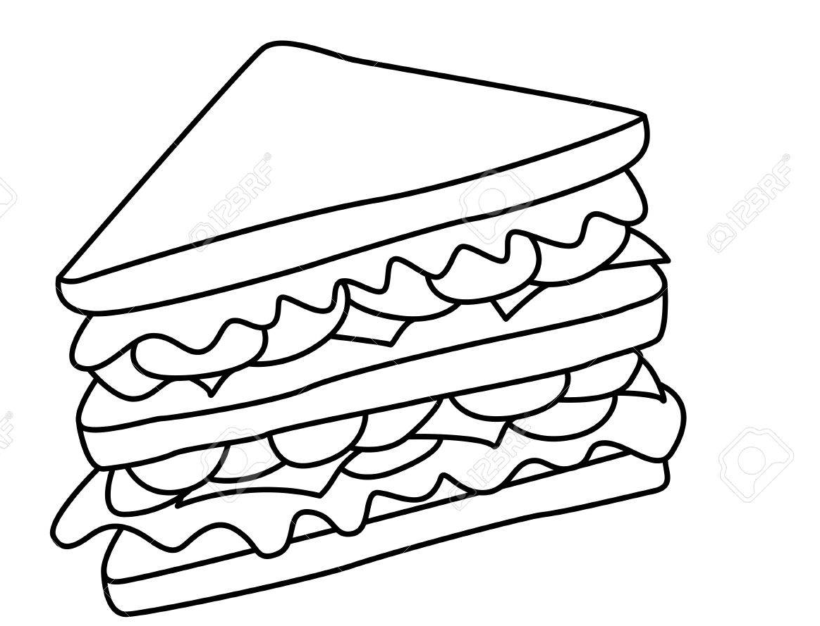  (B) | 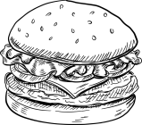  (C) | 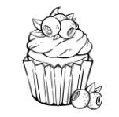  (D)

