桃園市立楊明國民中學103學年度第一學期第三次段考九年級英語科試卷
滿分100，共50題，請畫卡作答，答案卡上務必清楚畫記個人資料
班級： 座號： 姓名：
- 聽力，24%，共12題。
- 每題2分，共12分。
(一)辨識句意：根據聽到的內容，選出符合描述的圖片或符合圖片的描述。
- （C）(Ａ) 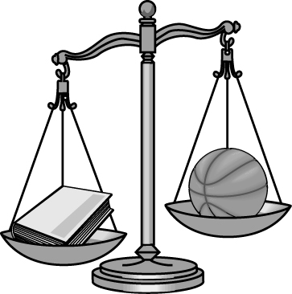(Ｂ) 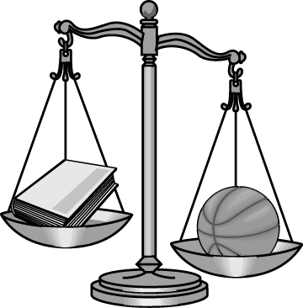(Ｃ) 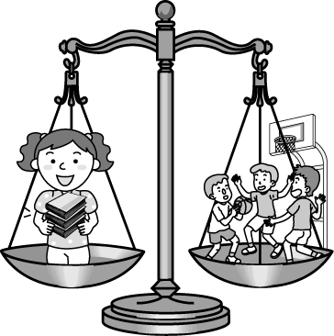
- （B）(Ａ) 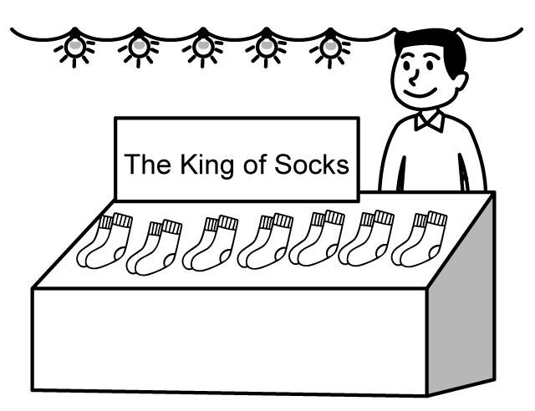(Ｂ) 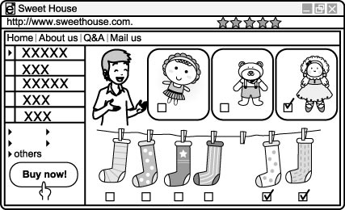(Ｃ) 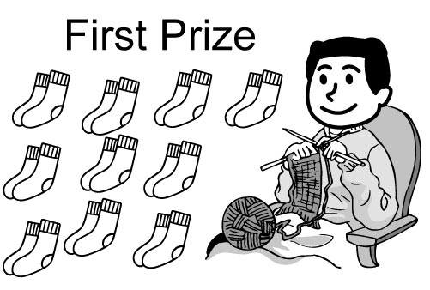
- （B）(Ａ) 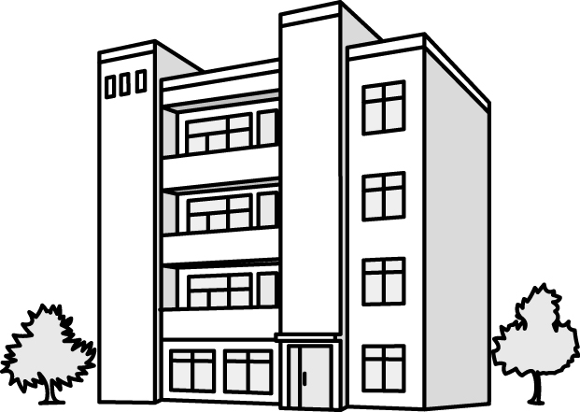(Ｂ) (Ｃ)
- （A）(Ａ) (Ｂ) 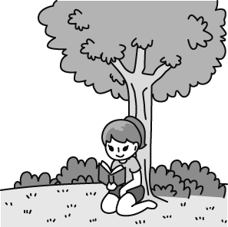(Ｃ) 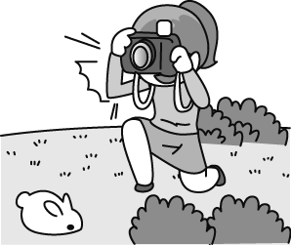
- （A）(Ａ) 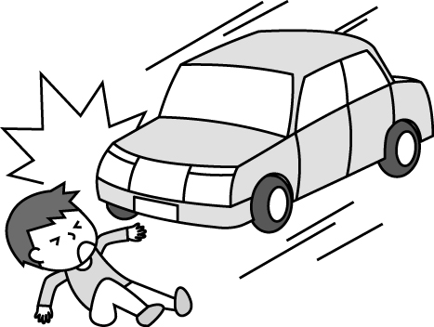 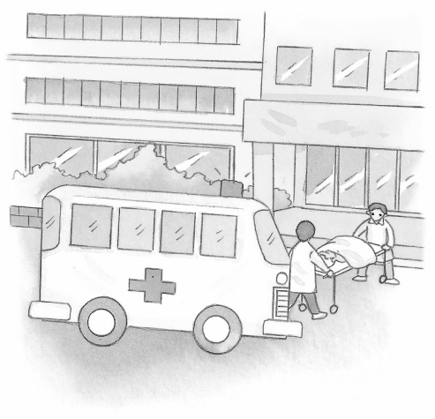(Ｂ) 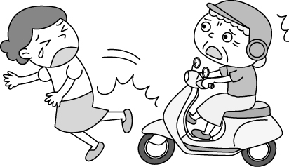 (Ｃ) 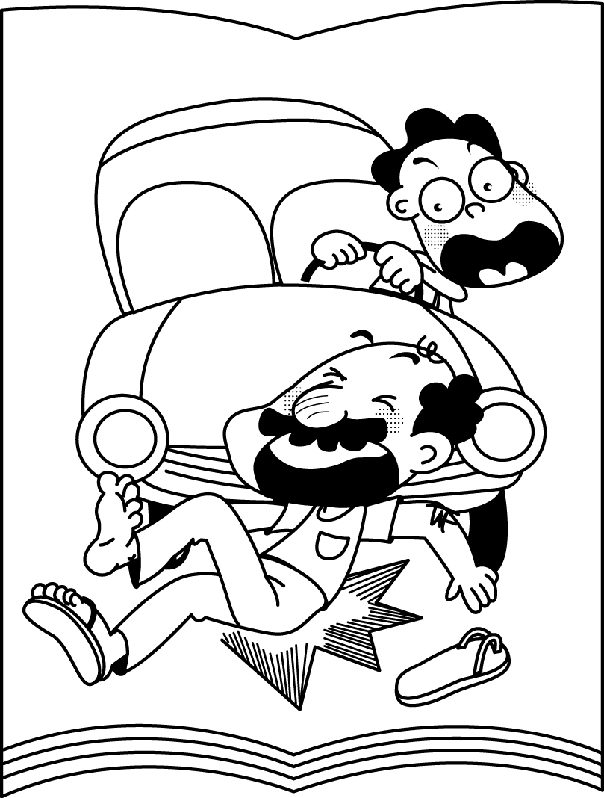
- （C）(Ａ) 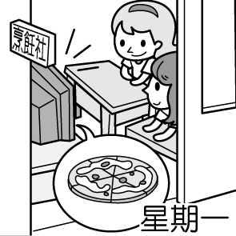(Ｂ) 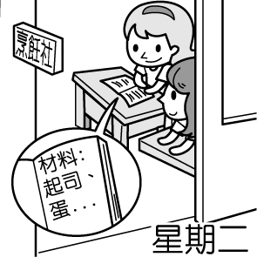(Ｃ) 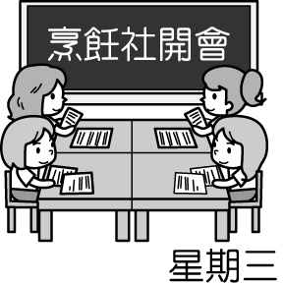

每題2分，共12分。請注意劃卡題號
- (二)基本問答：根據聽到的內容，選出一個最適合的回應或最適合的問句。
- C劃卡第7題(Ａ)Work hard, and you can win first prize.
(Ｂ)You are not smart enough to learn a foreign language well.
(Ｃ)Don’t say so. You sing and act well. Maybe you will become a great singer.
- B劃卡第8題(Ａ)Cheer up! You will grow healthy soon.
(Ｂ)Don’t worry. Take up a hobby from now on.
(Ｃ)When I get old, I want to live in a nursing home.
- C劃卡第9題(Ａ)He is good at rock music.
(Ｂ)Everyone should make their dreams come true.
(Ｃ)I don’t care. The most important thing is that I like her.
- A劃卡第10題(Ａ)No way! (Ｂ)Don’t follow me. (Ｃ)You can take a day off.
- C劃卡第11題(Ａ)Because he is little. (Ｂ)Because it is very cold. (Ｃ)Because it will snow more heavily.
- A劃卡第12題(Ａ) At a bakery. (Ｂ) In a library. (Ｃ) At a church.

- 單字及文法選填，50% (每題2分，共25題。)
A13.提供=(a)provide (b)star (c)garden (d)follow
A14.快樂=(a)unhappy (b)pleasure (c)aside (d)type
B15.事業=(a)prize (b)business (c)cover (d)alone
A16.精神=(a)spirit (b)stranger (c)dangerous (d)stamp
D17.高溫=(a)dull (b)rock (c)salt (d)heat
C18.Iris should pay attention ____the things that she is working on.(a)for (b)at (c)to (d)in.
C19.Can you show me how you____ the noodles? (a)bake (b)fix (c)fry (d)farm
D20.John makes a ____ by selling newspapers. (a)list (b)information (c)prisoner (d)living
A21.As____as Kate woke up, she went to the bathroom. (a)soon (b)fast (c)below (d)above
D22.Annabell likes eating popcorn, oysters, and ______(a)any more (b)lead to (c)no longer (d)so on.
D23.Studying is important, and ___.(a)neither is having fun (b)having fun isn’t, either (c)having fun is so (d)having fun is, too.
B24.Taylor is reading the book____.(a)to that Martin lent her (b)which Martin lent to her (c)who lent it to her (d)that Martin lent it to her
D25.The movie that they’re talking about______(a) are stories of successful people (b)have some sad moments (c)are simple for you to understand (d) let me feel dull.
C26. The picture_____ is mine. (a)who has a house (b)with has two apartments (c)with two dogs (d) which is having some mud
C27.Do you know the student____? (a)which loves playing chess (b)who in the white dress (c)with a big smile (d)on red shoes
B28.Iris loves the cat____. (a)jumps on the chair (b)which has a long tail (c)with the chair (d)who has a long tail.
B29.I chat online at night, and _____.(a)Emma is, too (b)Emma does, too (c)so is Emma (d)so do Emma.
A30.Harry isn’t shy, and_____.(a)Louis isn’t, either (b) Louis is, neither (c) Louis is, too (d) so is Louis.
C31.This photographer must be someone____(a)with happy (b)which love taking photos (c)who is good at taking photos (d) on orange pants.
B32.Betty is listening to the song ____(a)Kate wrote it (b)Kate wrote (c)which were wrote by Kate (d) that wrote by Kate.
A33.The cold weather won’t keep Jay from _____(a)getting up early on school days (b)wash the oyster shells (c)has a meeting with his boss (d)to make a living.
C34.The girls will have a nice winter vacation, and____.(a)so will the boys (b)so are the boys (c)so do the boys (d)so have the boys.
B35.Sam used to tell jokes, ______(a)she loves telling jokes (b)but she doesn’t now (c) she takes up a hobby (d)she cheers up everyone.
D36._______ students are excited about their winter vacation right after the final exam. (a)Few (b)Little (c)A lot (d)Dozens of
A37.Work hard, and your dream will ______.(a) come true (b)cheer up (c)take up (d)mind

- 閱讀測驗，26% (每題2分，共13題。)
題組1(38-41)
Shen Xinling and Her Photos
Photo I
The man in this picture is a farmer _38_ works over 12 hours every day. He only takes a day _39_ on the first day of the Chinese New Year. The water buffalo which helps him on the farm now is his sixth in the past 50 years.
Photo II
The woman who is walking in the mud makes money by farming oysters. Her fingers are covered _40_ cuts from the oysters’ sharp shells. She does not mind the cuts but sees them _41_ gifts because the oysters bring her money to raise a family of seven.
B38.(a)which (b)who (c)x (d)what
A39.(a)off (b)of (c)out (d)over
C40.(a)at (b)as (c)with (d)of
A41.(a)as (b)for (c)of (d) from

題組2 (42-46)
Robots
A robot is a machine. But it is not just any machine. It is a special kind of machine. It is a machine that moves. It follows
instructions. The instructions come from a computer. Because it is a machine, it does not make mistakes. And it does not get tired. And it never complains. Unless you tell it to!
Robots are all around us. Some robots are used to make things. For example, robots can help make cars. Some robots are
used to explore dangerous places. For example, robots can help explore volcanoes. Some robots are used to clean things. These robots can help vacuum your house. Some robots can even recognize words. They can be used to help answer telephone calls. Some robots look like humans. But most robots do not. Most robots just look like machines.
Long ago, people imagined robots. Over 2,000 years ago, a famous poet imagined robots. The poet’s name was Homer. His robots were made of gold. They cleaned things and they made things. But they were not real. They were imaginary. Nobody was able to make a real robot. The first real robot was made in 1961. It was called Unimate. It was used to help make cars. It looked like a giant arm.
In the future, we will have even more robots. They will do things that we can’t do. Or they will do things that we don’t want to do. Or they will do things that are too dangerous for us. Robots will help us fight fires. They will help us fight wars. They will help us fight sickness. They will help us discover things. They will help make life better.
D42. From paragraph(段落) 1, what isn’t so special about the robot?
instruction(n)指示
explore(v)探索
volcano(n)火山
vacuum(v)吸塵
recognize(v)認得
(a)It moves. (b)It follows instruction. (c)It never complains. (d)It gets tired.
D43. According to the writer, robots may be used to
(a) make cars (b) explore volcanoes (c)answer telephone calls (d)All of the above
C44.What is the main idea of paragraph 2?
(a) to show how easy it is to make a robot (b) to tell what a robot is (c) to describe the things a robot can do (d) to explain the difference between a robot and a machine
A45. According to the passage, when was the first real robot made?
(a) 1961 (b) 1900 (c) 2003 (d) 2000 years ago
C46.Which of these sentences correctly tells how the writer feels about robots?
(a) Robots are old. (b) Robots are confusing. (c) Robots are helpful. (d) Robots are dangerous.

題組3(47-50)
The Myth of Narcissus
In Ancient Greece lived a young man called Narcissus, who was greatly admired, because he was very handsome. Narcissus was very proud of his perfect face and body, and never lost the chance to look at himself in any part of water he happened to pass. He would lie for hours admiring his shiny dark eyes, thin nose, thin hips and curly hair around his perfect face. You would think an artist had come down from heaven to make such wonderful body as an image of love of beauty. One day, Narcissus was walking close to a precipice where the clear waters of a cold mountain pool mirrored his beautiful face. "You are handsome, Narcissus!" he told himself as he bent down to admire himself. "There's nobody so handsome in the whole world! I'd love to kiss you." Narcissus suddenly wanted to kiss his image, so he bent down closer to the water. But he fell down into the pool. Narcissus could not swim, so he died. But when the gods discovered that the most beautiful man on earth had died, they decided that such beauty could not be forgotten. The gods turned Narcissus into a flower which, to this day, grows in the mountains in spring, and which is still called Narcissus.
D47. How do you describe Narcissus?
(a)modest (b)dishonest (c)careful (d)proud
Greece(n)希臘
curly(adj)捲曲
precipice(n)斷崖bent(v)彎曲
C48. The word admired in the first sentence means
(a) hated and scared (b) funny (c) loved and respected (d) unfriendly
C49. Which job would Narcissus probably have if he were alive(活著) today?
(a) teacher (b) doctor (c) actor (d) gardener
A50. The gods turned Narcissus into a flower
(a)to remember him. (b)to beat him. (c)because he wanted. (d) as a joke.

